3)

CONSIDER ABOVE TABLE FROM Q1. CREATE A GRAPH AND STORE THE DATA IN MULTIFILE SYSTEM. PARTITION THE DTAT IN 2-WAY USING ROUND ROBIN PARTITION TYPE.

***GRAPH:***

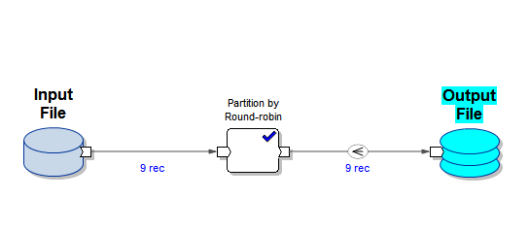

***UNIX COMMANDS:***

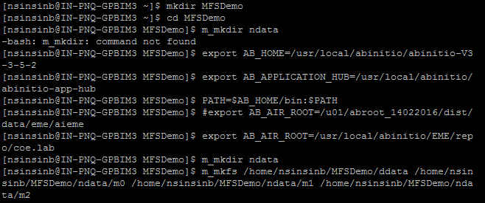

***INPUT FILE:***

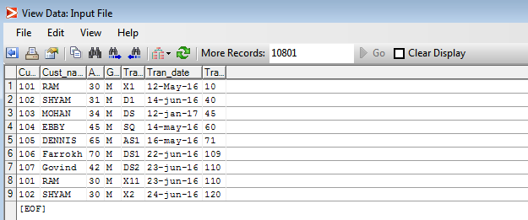

***ROUND ROBIN:***

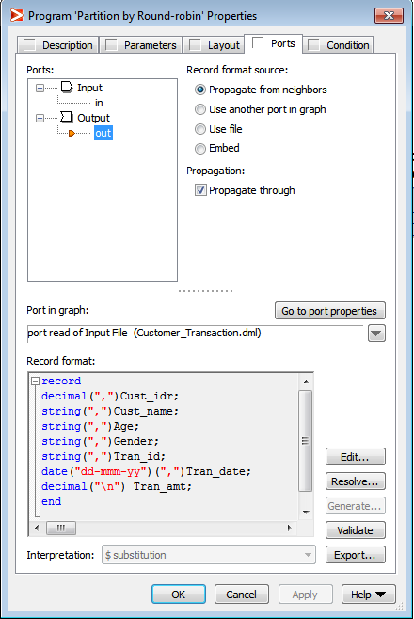

***OUTPUT FILE:***

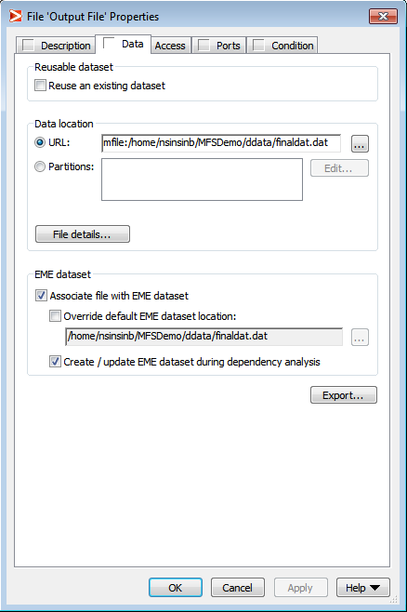

***OUTPUT ON UNIX :***

***OUTPUT M0:***

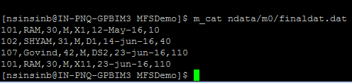

***OUTPUT M1:***

